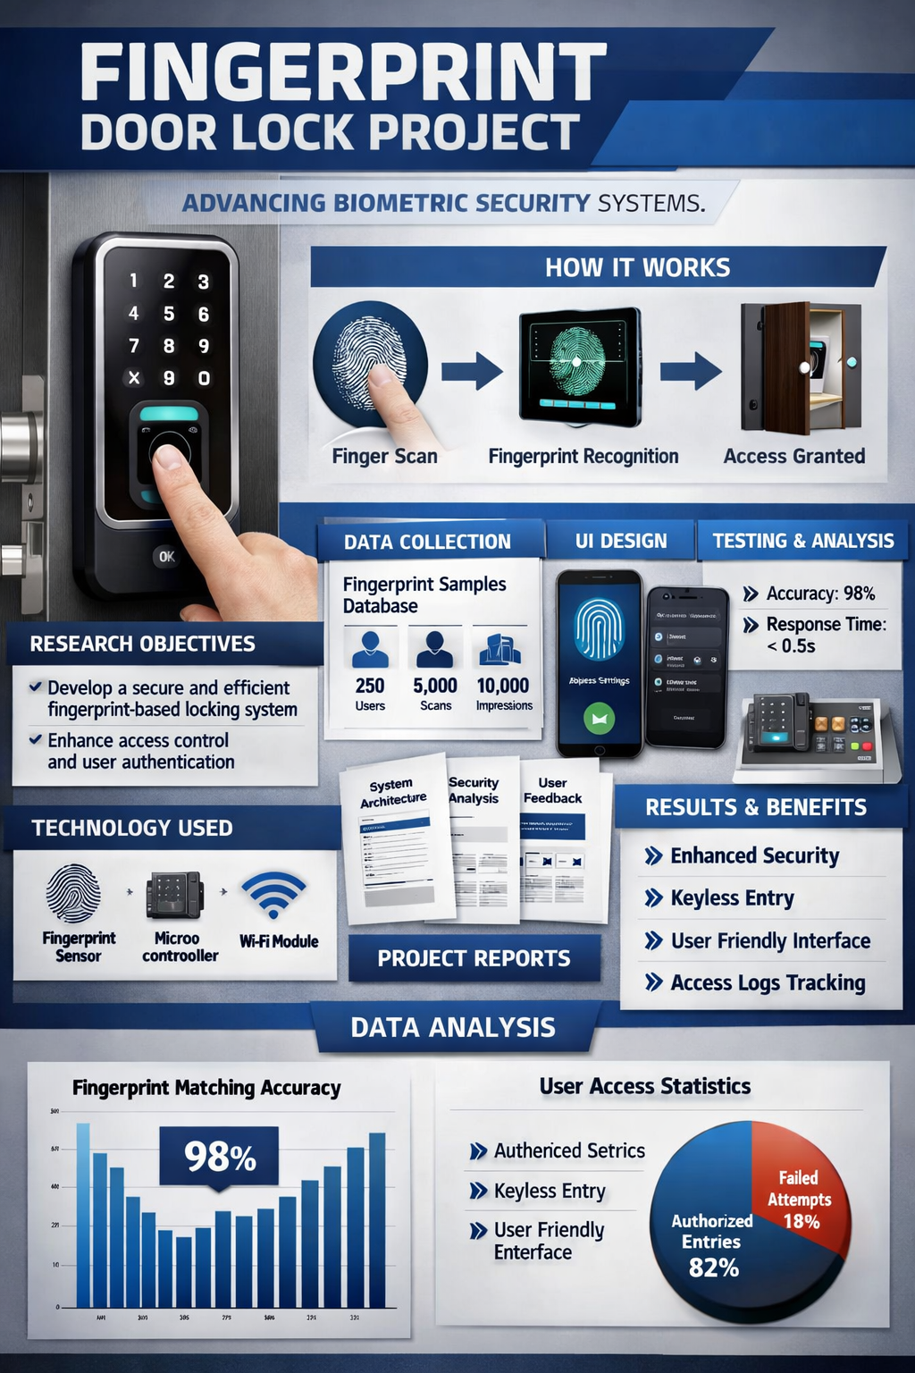

FINGER PRINT DOOR LOCK

🔑 Project Overview
A fingerprint-based door lock uses biometric authentication to enhance security. Instead of keys or PINs, it relies on unique fingerprint patterns to grant access.

📊 Research & Datasets
- Biometric authentication: Explore academic papers on fingerprint recognition algorithms.
- Fingerprint datasets: Public datasets like FVC2000, FVC2002, or NIST Special Database 4.
- Security reports: Studies on vulnerabilities and reliability of biometric locks.

🎨 Visuals & Posters
For your presentation, you’ll want:
- System architecture diagram: Showing sensor, microcontroller, and locking mechanism.
- Poster design: Highlighting features like security, ease of use, and modern design.
- UI mockups: Screens for enrollment, authentication, and admin settings.
Here’s a conceptual illustration to help you visualize:

🖥️ UI Designs
- Enrollment screen: For registering new fingerprints.
- Access screen: Showing success/failure messages.
- Admin dashboard: For managing users and logs.

📑 Reports & Documentation
Your project report should include:
- Introduction: Motivation and problem statement.
- Literature review: Existing biometric systems.
- Methodology: Hardware (Arduino/Raspberry Pi, fingerprint sensor) and software (matching algorithm).
- Results: Accuracy, speed, and reliability.
- Conclusion: Improvements like multi-factor authentication.

📽️ Presentation Flow
- Problem statement
- Proposed solution
- System design
- Implementation
- Results & demo
- Future scope

Would you like me to draft a sample poster layout for your project (with title, visuals, and key points), or a UI mockup design first?

